**VISHWAKARMA INSTITUTE OF INFORMATION TECHNOLOGY, PUNE**

**COMPUTER ENGINEERING DEPARTMENT**

**APRIL-MAY 2018**

**Synopsis**



**Group number: 41**

Group Members :

1. Shivani Hindukaje

2. Supriya Jadhav

3. Pradnya Shinde

4. Vrushali Warudkar

Email-ID :

hindukajeshivani@gmail.com

Mobile no :

8329439085

**Title: Smart social media bots**

**Objective :**

To create a system that manages marketing across various social media. To save human efforts and time required to execute a

marketing process. To manage company’s relationships and interactions

with potential customers to improve profitability.

**Abstract :**

Now days Social Media like Facebook, Twitter and many more play key role in advertising. Consumers are usually looking for content, entertainment, and connections. So the biggest problem while designing this advertising is content creation. Smart social media bots provide solution to this problem by generating content based on object detected in image that user wants to post. It provides the customer, a single platform through which executing campaigns on different social media is possible and also analyzing them based on likes and comments.

**Briefs about Contents:**

**1.Introduction :**

To create a Marketing Platform for executing multiple marketing campaigns on various social media effectively and also analyze their reach within the customers. Also to help the marketer to frame proper content for his social media posts. The platform should be able to do cross channel

execution i.e. posting and managing of Ads on any social media. It should thereby help to increase the company’s revenue by helping the marketer in framing a proper content for his posts and make the posts go on Trending on social media. In the end, the platform should display statistics of all

campaigns posts posted on all social media. Graphs will be displayed for different social media for all the marketing campaigns. Time line of posted posts is to be displayed. In the end, it should manage the every campaign of the registered company and display all results to those companies.

**2.Technical Details :**

Software Requirements:

1. Operating System:Ubuntu

2. IDE: pycharm

3. Programming Language: php,python

4. Hybrid Domain: Neural n/w, image recognition, hashtag analytics.

5. Permissions(API , Data Extraction , etc.) from all Social Media’s

Hardware Requirements:

1. Reliable Server

**3.Working :**

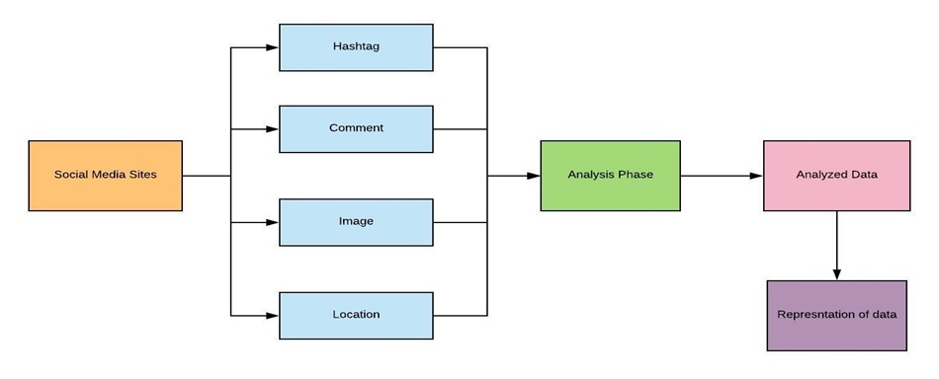

**4.Applications:**

- This helps businesses to accelerate their revenue by helping the marketer in framing a proper content for his posts and make the posts go on Trending on social media.

-Small scale companies can use this site promote their company and product.

**References/Bibliography:**

[1] KT Smith, "Study of Digital Marketing Strategies Targeting Millennials", *Journal of Consumer*

*Marketing*, vol. 29, no. 2, pp. 86-92, 2012.

[2] D. RyanC. Jones, "Understanding Digital Marketing: Marketing Strategies for Engaging the Digital

Generation", *Journal of Direct Data &Digital Marketing Practice*, vol. 10, no. 4, pp. 384-387, 2009.